
SMA 48th AGM Minutes
Friday 8th November 2024 11:20am online and in-person

Amgueddfa Cymru | National Museum of Wales

- Chair’s Opening Remarks
The Chair, Duncan Brown, opened the 48th AGM of the Society for Museum Archaeology.

- Apologies for Absence
No apologies were received.

- Acceptance of the minutes of the 47th Annual General Meeting being held online.
The minutes of the 47th AGM of the Society for Museum Archaeology were proposed by Philip Wise and seconded by Jenni Butterworth. The minutes were accepted by unanimous vote as a fair and accurate record.

- Matters arising
No matters arising.

- Summary of the activities of the Society since November 2023 based on pre-circulated reports from the Secretary, Membership Secretary, and Editor.
The following reports were pre-circulated and no questions were raised.

SMA Co-Secretaries Report
This has been our fourth year as co-secretary providing support to the committee and membership, arranging meetings, writing minutes, organising the AGM and answering enquiries. Our continued thanks go to the rest of the committee for their support and advice.

Most of the year’s committee meetings have taken place quarterly via Teams with one in person meeting in Cardiff.

This year we have supported the SMA Grant Sub-Committee with applications and committee colleagues with the finance administration of the Historic England Collections Use project.
Angie Bolton and Deborah Fox, SMA Co-Secretary, 13.10.24

SMA Membership Secretary Report
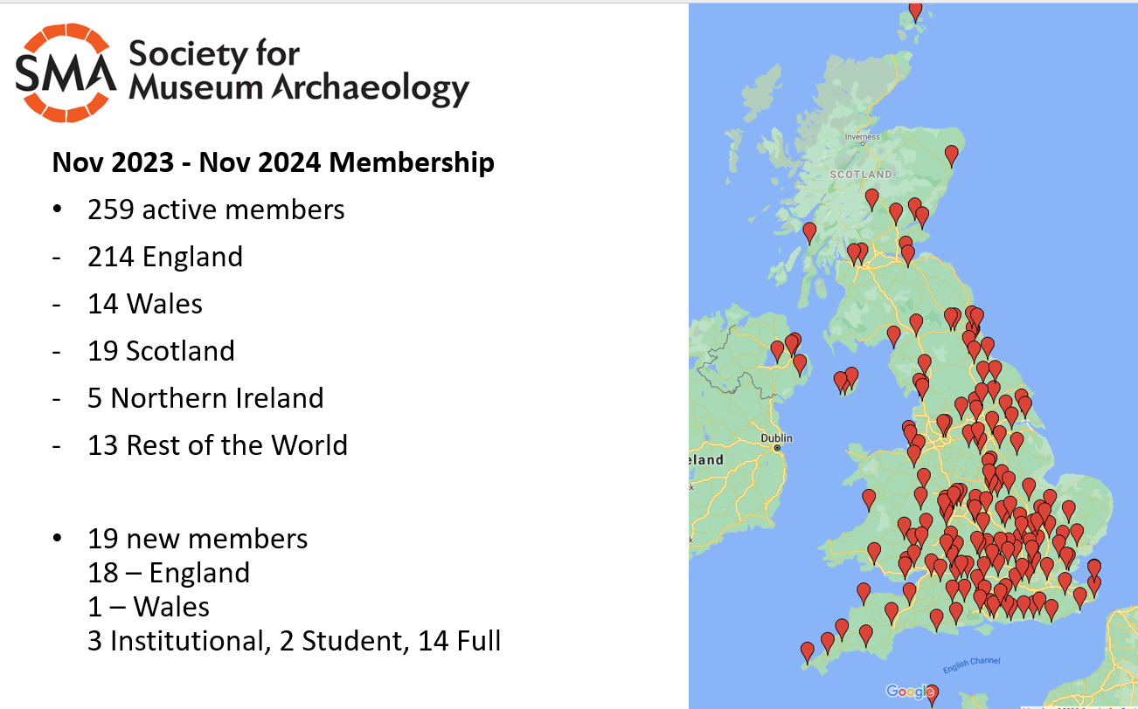

SMA Editor Report
General admin: A new designer was needed for the Journal, as the previous has retired. Quotes have been sought and a designer appointed in principle.

Journals in Draft:
2016 - Awaiting confirmation that the latest drafts are the most updated. Regardless, the 2016 papers will go to the designer for end of financial year (March 2025)

2017-2019- combined issue. Decision has been taken to combine these years into one issue, as the number of contributors available to provide their papers is limited. Around 10-13 papers are expected. Editing commenced already on received papers.

2020 and 2021- no journal.

2022 - Work has not begun on this issue, except for preliminary emails to authors.

Future journals: 2024 onwards - New approach and format for the Journal following the AGM.

- Hon. Treasurer’s Report and acceptance of accounts
Georgina thanked Michol for her contributions in the Treasurer role for which she has stepped down for personal reasons.

Treasurer’s Report on the accounts for the financial year 2023-24
ending 31 March 2024
Subscriptions
Membership subscriptions generated £2,051.00 representing 59 individual memberships, 26 institutional memberships, and 9 student memberships. This is a modest improvement on the previous year. Over 75% (£1,668) of this income was paid directly into the bank account, with the remainder being paid via PayPal. I want to thank the members for their continued support.
Conference
The September 2023 conference was ultimately postponed until 2024 and consequently resulted in no income or expenditure.
Project
The SMA received £19187.55 from Historic England for the project Use of Archaeology, of which £33707.73 was paid to our collaborators by the end of the financial year. In the previous financial year a project balance of £10,830.16 remained after expenditure, offsetting the greater expenditure in 2023-24.
Grant
The grants panel was pleased to award two grants towards projects furthering the aims of the Society; to Ironbridge Gorge Museums, and Historic England for. In total £1,119.46 was awarded between the successful applicants.
Miscellaneous
Very modest Interest was earned on the Society’s savings. A total of £426.96 was paid towards the cost of software subscriptions (Zoom and Dropbox). The SMA was also charged a total of £60 for business bank charges.
Summary
At the start of the financial year, the society had £34,601.25 in its current account and
£5,139.25 in its savings account, giving total assets of £39,740.50.
At the close of the financial year, the society had £20,556.12 in its current account and
£5,231.10 in its savings account, giving total assets of £25,787.22.
Accounts for the period 1 April 2023 to 31 March 2024
INCOME
Subscriptions | £2,051.00
Project (Use of Arch)  Interest | £19,187.55  £91.85
Total | £21,330.40
EXPENDITURE
Grant | £1,119.46
Software | £426.96
Charges | £90.47
Project (Use of Arch) | £33,707.73
Total | £35,344.52
TOTAL FUNDS
HSBC Current account | £20,556.12
HSBC Savings account | £5,231.10
Total | £25,787.22

Georgina Barrett, Acting Treasurer – Society for Museum Archaeology
4th October 2024

Gail Boyle proposed acceptance of accounts and Sian Isles seconded. The Society for Museum Archaeology 2023-24 accounts were accepted by unanimous vote.

- Elections to Committee 2024 – 2025

Chair
Ben Donnelly Symes – proposed by Gail Boyle and seconded by Jenni Butterworth

Newsletter Editor
Cecilia Levratto – proposed by Georgina Barrett and needs a seconder

Treasurer
Georgina Barrett - proposed by Deborah Fox and seconded by Angie Bolton

Training Officer
Peter Robinson – proposed by Jenni Butterworth and seconded by Angie Bolton

Ordinary member
Lori Rogerson – proposed by Angie Bolton and seconded by Deborah Fox
Kerry Whitehouse – proposed by Deborah Fox and seconded by Angie Bolton

There was no contest for any elected positions so Duncan Brown proposed all should be accepted together. The nominations were proposed by Gail Boyle and seconded by Philip Wise. The nominations were carried by unanimous vote.
Georgina Barrett offered to speak to any members who would be interested in the position of Assistant Treasurer which is still vacant.
Duncan Brown suggested members interested in joining the committee in one of the vacant Ordinary Member positions could speak to a member of the committee and be co-opted at a committee meeting.

- Any Other Business
There was no additional business.

