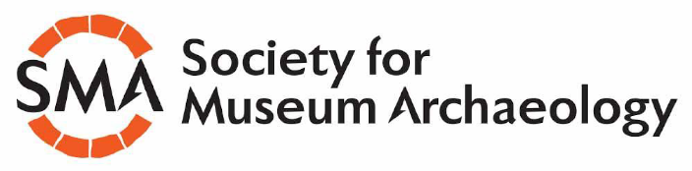

Celebrating 50 years of the Society for Museum Archaeology
SMA Annual Conference Part 2

Programme

Hosted Online
4th December 2025

Due to adverse weather conditions, sessions on Friday 14th of November were disrupted. The programme of rescheduled talks and the SMA AGM are listed below.

We thank both speakers and attendees for their patience through this unexpected disruption and thank you all for your continued support.

Celebrating 50 years of the Society for Museum Archaeology
SMA Annual Conference Part 2
4th December 2025

13:00 - 13:05 | Welcome and Introduction
 | Elsa Price, Lead Curator of Archaeology, National Museums Liverpool
13:05 - 13:25 | ‘Times they are a changing’ – how do we best communicate archaeology for multiple audience needs?
 | Neil Redfern, Executive Director, Council for British Archaeology
13:25 - 13:45 | It’s not all about the finds: managing Kings Weston Roman Villa
 | Kate Iles, Senior Curator of Archaeology, Bristol Museums
13:45 - 14:05 | Putting the archaeology back into the antiquarian: analysing the Dr HA Fawcett Collection of Typology for archaeological significance.
 | Gail Boyle, Freelance
14:05 - 14:25 | Archaeology and the persistence of mystery
 | Jenny Durrant, Freelance collections and ethics consultant
14:25 - 14:30 | Comfort Break
14:30-14:45 | Questions
14:45 - 15:00 | AGM & Awards
 | Ben Donnally-Symes, Chair, SMA
15:00-15:10 | 2024 Grant Recipient: Access For All: Treasures of Oxfordshire
 | Angie Bolton, Curator of Archaeology, Oxfordshire Museum Service
15:10-15:20 | 2024 Grant Recipient: The Bidston Hogback Stone
 | Vanessa Oakden, Curator of Regional and Community Archaeology, National Museums Liverpool
15:20-15:30 | Questions and Close

