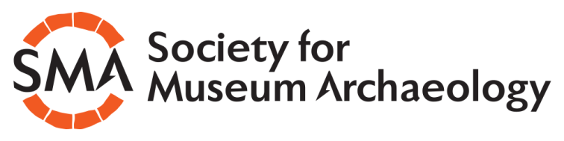

April 2020: SMA news update from the Chair

Hello,

I hope you are all safe, healthy and coping in these strange days. It might be helpful, I think, to have something to look forward to, so here are a few things I hope you'll be interested in.

The SMA NEWSLETTER, which would usually be a spring issue, will be slightly delayed. Philip Wise, our Newsletter Editor, has reported a decline in copy, which is understandable at the moment. He is actively pursuing contributions and we're hoping to share lockdown experiences, so if you want to join in with a short piece, please contact Philip, whose details can be found on the committee page of the SMA website. The newsletter is planned for July/August.

We are continuing to plan this year's ANNUAL CONFERENCE, so please put these dates in your diary. If we are close enough to normality, we'll be gathering in Cardiff and St. Fagan's on the 12th and 13th NOVEMBER. The theme, which we hope will be appropriate, is 'Rebirth and Renewal' and is partly stimulated by the recent work at St. Fagan's that led to it becoming Museum of the Year for 2019.

The conference is always a brilliant opportunity to hear some inspirational talks, meet old friends, make new ones and generally recharge your enthusiasm. This year, I think, we'll need it more than ever and St. Fagan's will be a fantastic venue. If you'd like to give a talk about a new gallery, exhibition, collections initiative or any other related event or activity then please contact our Secretary, Kat Baxter. Further information will be sent out with the newsletter towards the end of the summer.

The conference will also host our annual SMA AWARDS presentation, the first of which took place in Chester last year. If you have any nominations for this year, please send them to Kat Baxter.

The SMART programme that we launched last year is drawing to a close, with our new Standard for the Care of Archaeology Collections in the design stage. You should soon be hearing more about that from Gail Boyle, the project lead. She and the team of people who worked with her to deliver the Standard, the workshops and the mentoring scheme all deserve huge thanks for seeing this through. Keep an eye on the website for more information.

There may be some concern, as furlough continues, or job security becomes uncertain, that keeping up your SMA SUBSCRIPTION will be more difficult this year. The committee will be considering how best to help our members. If you have any particular views on this, or wish to share your own concerns or circumstances, please contact me and I will collate everything together for the committee to discuss. We want you all to remain members and we will help you to do that.

Stay well and I hope to see you in November.

Duncan Brown
Chair SMA

