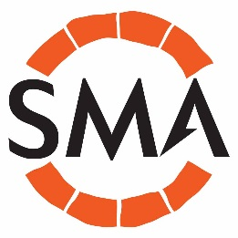

SMA Committee 2019-2020

Chair Duncan Brown Duncan.Brown2@HistoricEngland.org.uk
Vice Chair Anooshka Rawdon dimachaeri@hotmail.com
Secretary Kat Baxter Katherine.baxter@leeds.gov.uk
Treasurer Lucy Creighton Lucy.Creighton@ymt.org.uk
Membership Secretary Nick Booth membership@socmusarch.org.uk
Editor Martha Jasko-Lawrence Martha.Jasko-Lawrence@museums-sheffield.org.uk
Newsletter Editor Philip Wise Philip.wise@colchester.gov.uk
Training Officer Amal Khreisheh amal.khreisheh@swheritage.org.uk
Digital Officer Gail Boyle gail.boyle@bristol.gov.uk
Wales Rep Sian Iles sian.iles@museumwales.ac.uk
Scotland Rep
N. Ireland Rep Greer Ramsey greer.ramsey@nmni.com
Member Michol Stucco mstocco@museumoflondon.org.uk
Member Catriona Wilson Catriona.mary.wilson@gmail.com
Member Deborah Fox DFox@worcestershire.gov.uk
Member Claire Tsang Claire.Tsang@HistoricEngland.org.uk
Member Kevin Booth Kevin.Booth@english-heritage.org.uk
Member Elizabeth Montgomery Elizabeth.Montgomery@cheshirewestandchester.gov.uk

