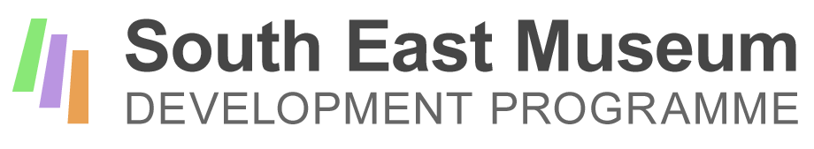
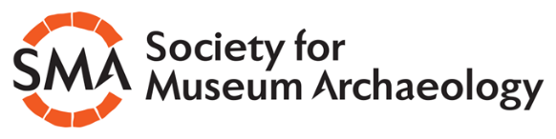

SMART Project: Application form for mentors
Thank you for your interest in working with the Society for Museum Archaeology on this pilot mentoring project. Please answer the following questions and return the form with a short summary CV in a format which shows us what experience you have that is relevant to this project.
1. Your name and contact details
Name:
Current role and organisation (if applicable):
Phone number (the best number to contact you if we need to discuss this application):
Email:
Museum web address, if applicable:

2. Tell us about your current role and the collections you work with and other relevant experience
We need to know about your current and previous roles so that we can see what experience you have to draw on in supporting mentees. Include details about the scope of the collections you have worked with. Please limit your answer to 250 words maximum.

4. Please review the competency matrix for Museum Archaeology, published by SMA and CIfA: https://www.archaeologists.net/sites/default/files/Museum%20Archaeology%20specialist%20competence%20matrix_final.pdf
Check the relevant box to tell us at which level you would rate your skills:
Practitioner ☐
Associate ☐
Member ☐
5. Tell us why you would like to participate as a mentor in this programme.
Please limit your answer to 100 words maximum

6. Tell us about your previous experience as a mentor or in skills development.
As well as any mentoring you may have undertaken in a formal capacity, please include other relevant activities, such as supporting trainees or volunteers. You can also include experience from voluntary roles and outside the museum sector. Please limit your answer to 250 words maximum.

7. Please click here to confirm that you have discussed your application with your line manager (or other relevant person, such as the Chair of your museum) and have their approval.☐
8. Please click here to confirm that you have attached a summary CV .☐
For help completing this form, please contact Helen Wilkinson, who is the consultant delivering this project: 0771 966 7102, or helen@museumconsultancy.co.uk
Applications should be returned to Katherine Baxter, SMA Secretary by 12 noon on Monday 22nd July, katherine.baxter@leeds.gov.uk

