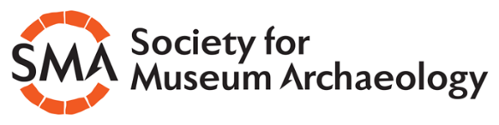
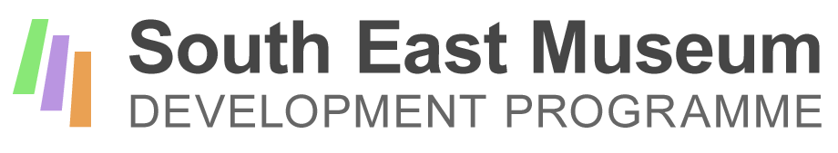
SMART Project mentoring: Application form for mentees
Thank you for your interest in working with the Society for Museum Archaeology on this pilot mentoring project. Please answer the following questions and return the form with a short summary CV in a format which shows us what museum experience you have to date.
1. Your name and contact details
Name:
Role in the museum:
Phone number (if we need to discuss this application):
Email:

2. Name of your museum, and web address

3. Tell us about your museum.
Please limit your answer to 250 words maximum. Some things to include:

- How it is run (e.g. by a local authority, or independent etc)
- Whether it is Accredited
- The nature and scope of its archaeological collections and how they relate to the museum’s other collections (if relevant)
- Your visitor offer and your audience – for example, approximate visitor numbers and what opportunities audiences have to see and engage with your archaeology collections

4. Tell us about the people who would be participating in the project, and about what other people work in your museum.
Please limit your answer to 250 words maximum. Some things to include:

- Who would be participating? You as an individual, or a group of people?
- Are you (and any other potential participants) a paid member of staff or a volunteer?
- What other responsibilities do you have as well as your work with the archaeological collections?
- Is anyone else involved in the care and interpretation of the archaeological collections?

5. Tell us about what you feel are the main gaps in your skills and knowledge, with reference to the management of archaeological collections. Tell us how you think working with a mentor would make a difference to you as an individual.
Please limit your answer to 250 words maximum.

6. What difference do you think taking part in the programme would make to your organisation. What would the museum be able to do that it cannot do at the moment?
Please limit your answer to 250 words maximum.

7. Please click here to confirm that you have discussed your application with your line manager (or other relevant person, such as the Chair of your museum) and have their approval.☐
8. Please click here to confirm that you have attached a summary CV .☐
For help completing this form, please contact Helen Wilkinson, who is the consultant delivering this project: 0771 966 7102, or helen@museumconsultancy.co.uk
Applications should be returned to Katherine Baxter, SMA Secretary by 12 noon on Monday 22nd July, katherine.baxter@leeds.gov.uk

