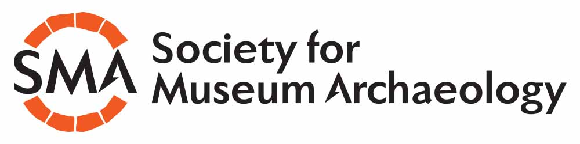

Society for Museum Archaeology
Annual Conference 2017
Millennium Gallery, Sheffield
Thursday 2nd – Friday 3rd Nov 2017

CALL FOR PAPERS
Deadline July 31st 2017

The Society for Museum Archaeology’s Annual Conference will return to the north of England this year, this time to the Millennium Gallery in Sheffield. The conference offers an opportunity to network with colleagues, hear exciting papers and take part in discussions around museum archaeology.

This year’s theme is:
It’s not just about the archaeology – or is it?

When you work with archaeology in museums, you can end up doing a huge range of activities. Whether it be the delivery of exhibitions, engagement and events, or good old-fashioned collections management, what is the role of the modern museum archaeologist?
This year’s conference is an opportunity to celebrate all things good….or bad…about what we do and how we do it!

Please send any proposals or queries to the society’s secretary at
katherine.baxter@leeds.gov.uk

